Updated Design Document
Portfolio of Evidence, Part 3
App: Vibe , a mood and purpose-based venue discovery app

Document Update
This document has been updated to record the progress made from the original planning and design specification to the final Vibe application. It retains the original purpose, user-centred design considerations and core innovative ideas, while adding the implementation details supplied for the final build.
We updated this documentation to include the final application features, the revised technology stack and deployment approach, evidence requirements, final release notes, and the GitHub README and GitHub Actions requirements. The README on GitHub must contain the comprehensive project report, supporting images, and release notes.

Introduction
This document sets out the full design for Vibe, an Android application that helps users discover cafes, coworking spaces, and study spots based on mood or purpose (for example "quiet", "social", or "focus") rather than by category alone. It follows on from the Research Report, which identified that existing vibe-based discovery apps (Vibemap, VibeCheck, and Inside Vibe) focus almost entirely on nightlife and social occasions, leaving a clear gap for everyday, purpose-driven discovery. This document details the app's requirements, user interface design, API and database design, system architecture, data model, and project plan, in enough detail that another developer could build the app from this specification alone.

Problem Statement and Solution

The problem
Conventional venue discovery often starts with categories, keywords or distance. These approaches do not always help a user identify whether a space suits the activity they want to do. A user looking for concentration, group work or affordable Wi-Fi needs information about the atmosphere and facilities of a venue.

2The Vibe solution
Vibe makes mood and purpose the starting point of discovery. Users are presented with a mood picker and can filter results using relevant sub-tags. Venue details include a “Why this matches” explanation so that users can understand which tags contributed to a recommendation.

App Overview
Name: Vibe
Icon concept: a location pin in dark green containing an orange wave line, representing a search that adapts to mood rather than a fixed category. The wave motif is reused across the app (e.g. loading states) to keep the identity consistent.

Innovative features:
- Mood/purpose-based search as the primary navigation method, instead of category or keyword search.
- A "why this matches" explanation on each venue's detail screen, showing which tags contributed to the match and how many users confirmed them , this builds trust in the recommendation rather than presenting it as a black box.
- Offline-first favorites: saved venues remain available without a connection, with a visible pending-sync indicator for actions taken while offline.
- A pluggable venue data layer (IVenueDataProvider) that allows the underlying data source (currently BizData) to be swapped for a paid provider such as Geoapify or Google Places later, without changing the rest of the app.

Detailed Requirements

Authentication
Users register with an email and password. Passwords are never stored in plain text: the API uses ASP.NET Core Identity's built-in password hashing (PBKDF2) before persisting anything to the database. On login, the API validates credentials and issues a JWT bearer token, which the Android app stores securely and attaches to subsequent requests. As a stretch feature, Google Sign-In (SSO) is offered as an alternative to email/password, reducing friction for first-time users.

Settings
Users can change their preferred language, default search area, and notification preferences from the Settings screen. Changes are sent to the API via a PUT request and persisted against the user's profile, so preferences follow the user across devices rather than being stored only on-device.

REST API and Database
The Android app never accesses a database directly. All data operations go through a REST API built in ASP.NET Core, which uses Entity Framework Core to read and write to a PostgreSQL database. The API is also responsible for calling the external BizData venue API and merging that data with the app's own mood/tag data before returning it to the client.

Offline Mode with Sync
Favorited venues are cached locally using Room DB, so they remain viewable without an internet connection. If a user saves or removes a favorite while offline, the change is written to a local SyncQueue table with a "pending" status. When connectivity returns, a background sync worker pushes queued changes to the API and updates their status to "synced". This is scoped only to the Favorites feature for the initial release, rather than the whole app, to keep the offline logic manageable within the project timeline.

Real-Time Notifications
Firebase Cloud Messaging (FCM) is used purely as a delivery channel for push notifications; it does not replace the app's database or API. When a relevant event occurs on the backend (for example, a new venue matching a user's saved mood is added nearby), the ASP.NET Core API calls the Firebase Admin SDK to trigger a push notification, which FCM then delivers to the Android device. The Android app registers for FCM on login and listens for incoming messages.

Multi-Language Support
The app supports English plus two South African languages (isiZulu and Afrikaans), covering the primary UI strings
, screen titles, buttons, mood tag names, and settings labels. Strings are stored in per-locale string resource files (strings.xml) as is standard for Android, and the user's language choice is saved to their profile via Settings so it is remembered across devices.

Future Roadmap
A small number of additional features were considered during the design phase and deliberately excluded from the initial build to keep the core loop achievable within the project timeline: a personal "vibe history" timeline of visited venues, a gamified achievements/profile system, and richer community review content. These remain candidates for a future iteration once the core mood-search experience has been validated with real users.

User Interface Design
The app consists of six core screens. Each mockup below uses the app's brand colours: dark green (#1B4332), orange (#E85D04), and cream (#F5F0E8).

1. Login / Register
Entry point for the app. Users log in with email and password, or via Google SSO. New users can navigate to a registration form from this screen.
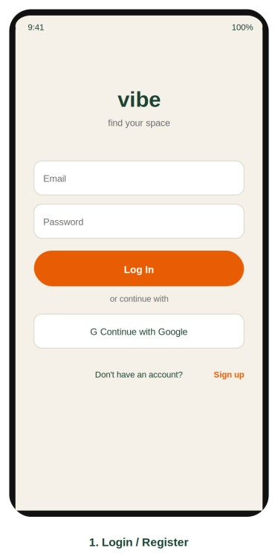

2. Home / Mood Picker
The main hub after login, reachable at any time from the bottom navigation bar. Users select a mood/purpose chip (Quiet, Social, Focus, Creative, Cheap Wifi) to search, and can see a summary card and recently saved venues.
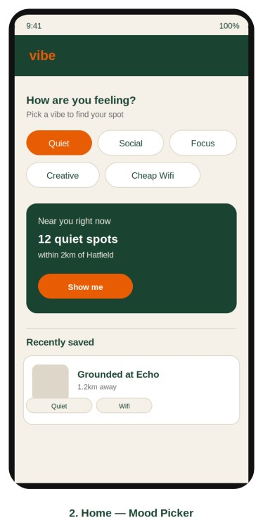

3. Results List
Shows venues matching the selected mood, sorted by distance, each with a photo, distance, open/closed status, and mood tags.
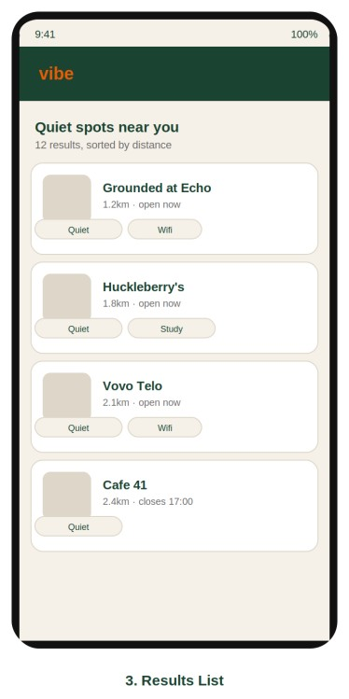

4. Venue Detail
Full information for a single venue: tags, hours, and a "why this matches" section explaining the recommendation. Includes a Save to Favorites button.
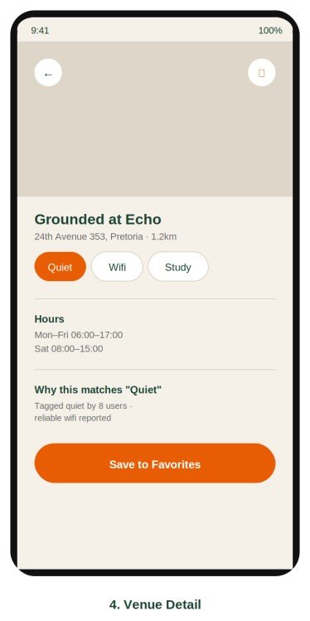

5. Favorites
Saved venues, cached locally so they remain viewable offline. Items saved while offline show a pending-sync indicator until the app reconnects.
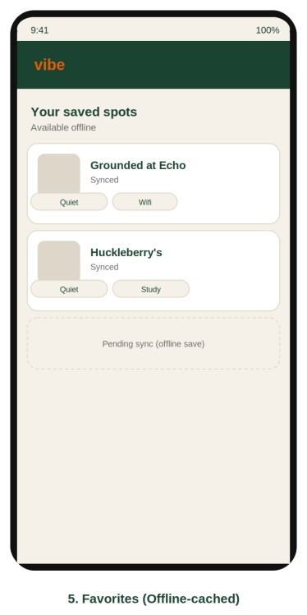

6. Settings
Language, default search area, notification preferences, offline data status, and account/logout.
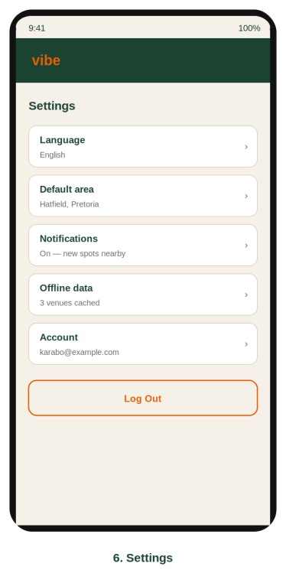

Navigation Diagram
Home, Favorites, and Settings are reachable at any time via a persistent bottom navigation bar once logged in. Results and Venue Detail are reached by drilling down from a mood search, and a venue can be saved directly to Favorites from its detail screen.
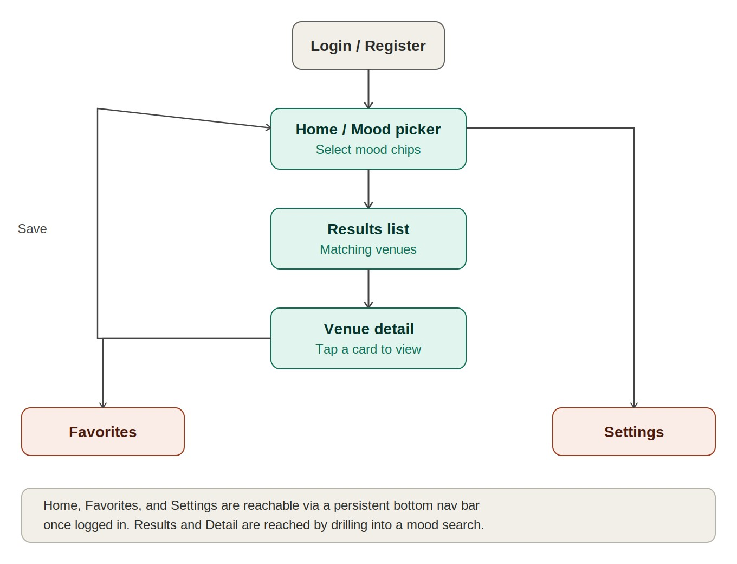

API Design
The backend is a custom REST API built with ASP.NET Core (.NET 10) and Entity Framework Core, hosted on Azure App Service (consistent with the tooling used elsewhere in the course). The API is the single point of contact for the Android app: it owns the PostgreSQL database, calls the external BizData venue API for venue search, and triggers Firebase Cloud Messaging for push notifications. An existing API (BizData, a free OpenStreetMap-based business data API) is used for venue search rather than building venue data collection from scratch; it is wrapped behind an IVenueDataProvider interface so the underlying provider can be swapped later (for example to Geoapify) without changing any other part of the system.
Key endpoints:
- POST /auth/register, POST /auth/login, POST /auth/google — account creation and authentication
- GET /venues?mood={tag}&lat={lat}&lng={lng} — returns venues matching a mood, merging BizData results with the app's own tag data
- GET /venues/{id} — full detail for a single venue, including tag breakdown
- POST /favorites, GET /favorites, DELETE /favorites/{id} — favorite management; this is the endpoint the offline sync queue targets
- PUT /settings — updates language, default area, and notification preferences
Database: PostgreSQL, accessed via Entity Framework Core (Code First). PostgreSQL was chosen over Firebase/Firestore for the primary data store because the app's data is relational by nature (users, venues, tags, and favorites all reference one another), which EF Core and a relational database model more naturally than a document store. Firebase is used only for its Cloud Messaging service, not as the primary database.

System Architecture (UML)
The diagram below shows how the API connects to the other systems in the application: the Android client, the PostgreSQL database, the external BizData API, and Firebase Cloud Messaging.
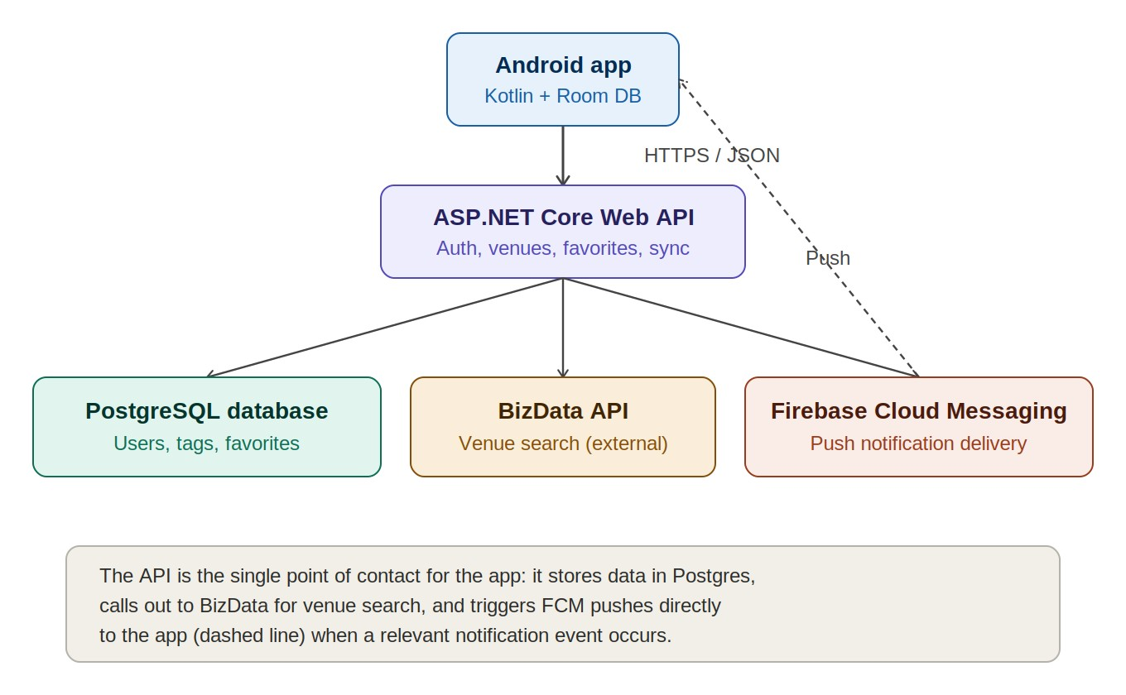

Data Captured and Stored
The table below lists the data the app needs to capture from the user or from external sources, along with the data type used for each field.
Field | Entity | Data type | Notes
Email | User | string (unique) | Used for login; stored hashed via ASP.NET Identity
PasswordHash | User | string | Encrypted, never stored in plain text
PreferredLanguage | User | string (enum) | e.g. "en", "zu", "af"
DefaultArea | User | string | User's default search location
VenueId | Venue | int / GUID (PK) | Primary key
ExternalRefId | Venue | string | BizData/OSM reference ID
Name | Venue | string | Venue display name
Latitude / Longitude | Venue | decimal | Used for distance sorting
Address | Venue | string (nullable) | May be blank depending on source data
OpeningHours | Venue | string (nullable) | May be blank depending on source data
TagId | Tag | int (PK) | e.g. Quiet, Social, Focus
TagName | Tag | string | Display label for the mood/purpose chip
VoteCount | VenueTag | int | Number of users who confirmed this tag for a venue
FavoriteId | Favorite | int (PK) | Primary key
SavedAt | Favorite | datetime | Used to sort recently saved
SyncStatus | Favorite | string (enum) | "synced" or "pending" — used for offline mode

Project Plan
The project is broken into granular tasks rather than single large milestones, with dedicated time allocated for integration testing and bug fixing before submission.

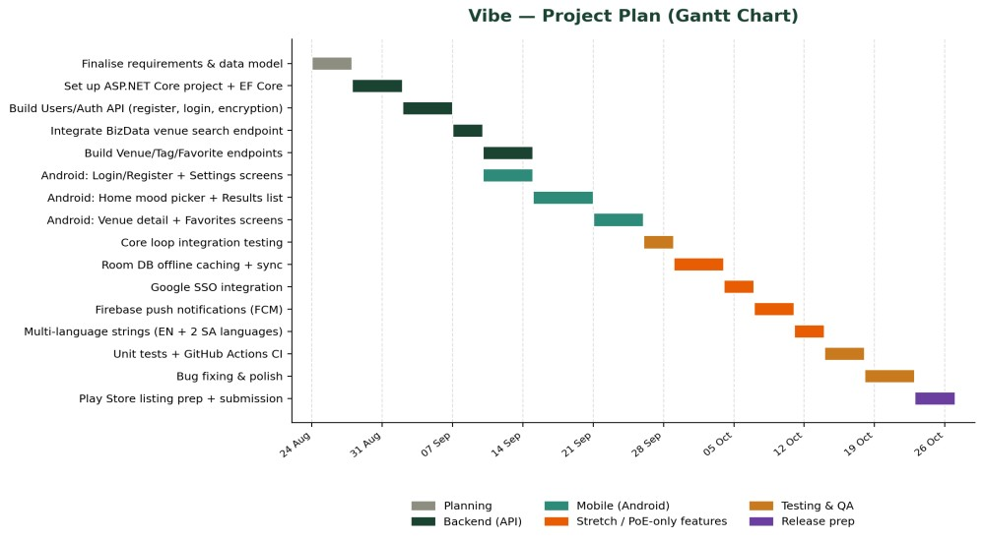

UPDATED

Design Considerations

Frictionless discovery
A two-column grid with rich venue imagery helps users recognise a suitable space quickly. Mood selection and contextual sub-tag filters reduce the need to enter detailed search terms.

Trust through transparency
The venue detail screen includes a “Why this matches” section explaining the tags associated with a result, rather than presenting a recommendation without an explanation.

Consistent visual identity
The app uses dark green (#1B4332), orange (#E85D04) and cream (#F5F0E8). The palette is intended to feel calm, focused and welcoming.

Robust error handling
The app provides a controlled failure state when network access is unavailable or a request cannot be completed, instead of allowing the application to crash.

Offline-first favourites
Room DB stores saved venues locally. Changes made offline are marked as pending sync and are queued for synchronisation when connectivity returns.

Accessibility and language choice
English, isiZulu and Afrikaans resource strings support a wider range of users. Language selection is available through Settings.

4.2 Innovative features implemented

Mood-based Discover feed
The main discovery experience is organised around a selected mood or purpose. Sub-tag filters change according to the selected mood. For example, Social can show Lively Music and Group Seating, while Cheap Wifi can show Power Outlets.

Why this matches
Venue details explain which tags caused a venue to appear in the results. This supports transparency and helps users understand recommendations.

Offline-first favourites
Users can save venues without an internet connection. Room DB stores local data and pending changes, which are queued for synchronisation when connectivity is restored.

Multi-language support
The interface includes English, isiZulu and Afrikaans. Localised strings cover interface labels, buttons and mood names, with language selection available in Settings.

Real-time push notifications
Firebase Cloud Messaging is integrated to notify users about new venues that match saved moods.

Google Single Sign-On
Google Sign-In is provided alongside email/password authentication to simplify onboarding.

Map view integration
Users can switch from the Discover list to an interactive map view.

Pluggable venue data design
The original design specified an IVenueDataProvider abstraction so that a venue data source could be replaced without redesigning the rest of the application. Retain this as a design principle where it is present in the final code.

System Architecture and Technology Stack
Vibe uses a client-server architecture. The Android client communicates with a REST API rather than connecting directly to the primary relational database. The API manages application data and communicates with the database and supporting Firebase services.

Android client
Kotlin, XML layouts, MVVM architecture, Retrofit for networking, Room DB for local/offline data, and Glide for image loading.

REST API backend
ASP.NET Core (.NET 8) with Entity Framework Core. The final implementation information supplied records deployment on Render.

Relational database
PostgreSQL hosted on Render for user, role and relational venue data.

Firebase services
Firestore is used for real-time synchronisation and user preferences, while Firebase Storage hosts venue imagery. Firebase Cloud Messaging is used for push notifications.

Authentication
ASP.NET Core Identity/JWT for application authentication and Google Sign-In for SSO. Passwords are hashed rather than stored in plain text.

CI/CD
GitHub Actions is used to automate application builds and unit-test execution on pushes to the main branch.
Implementation update: the original Part 1 design described ASP.NET Core hosted on Azure App Service and identified Firebase primarily as the FCM delivery channel. The final implementation details supplied for this update instead identify a .NET 8 API deployed on Render, PostgreSQL hosted on Render, and additional Firebase services (Firestore and Storage). This section records the final implementation as reported.

Database and API Design

Database design
PostgreSQL is the primary relational database for users, roles and venue-related records. Room DB provides local storage for offline favourites and pending synchronisation. Firebase Firestore supports the real-time synchronisation and preference functions described for the final implementation, while Firebase Storage stores venue images.

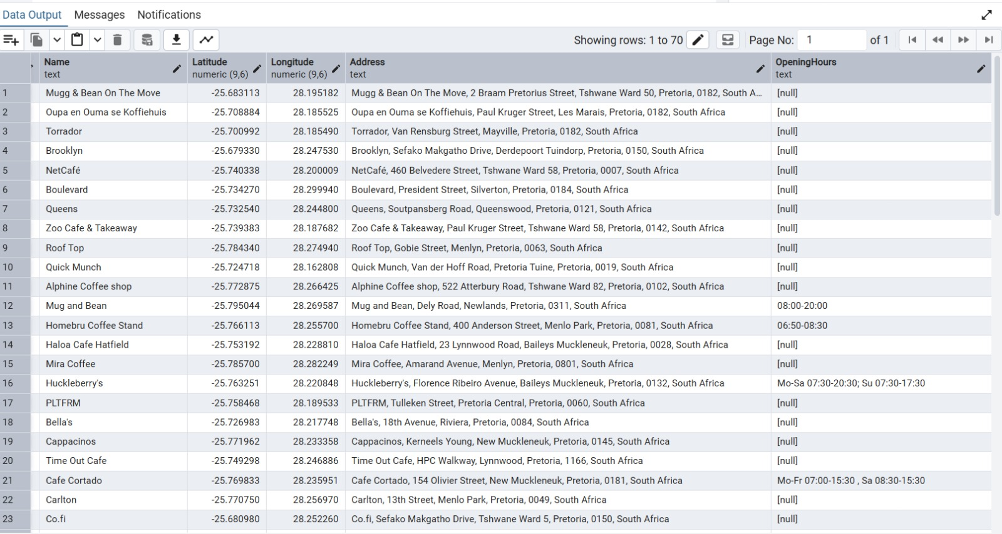

Updated User Interface Design

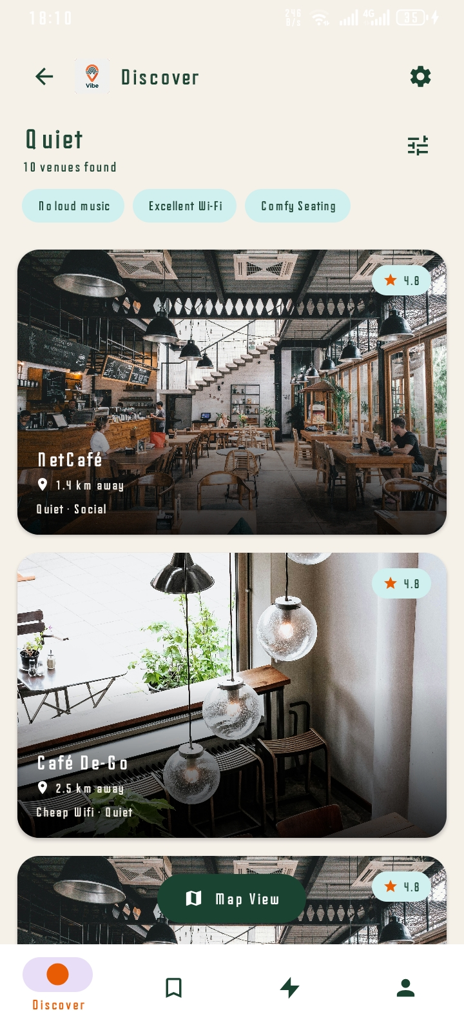

Quiet Discover Screen: Displays the main "Quiet" feed, showing venues like NetCafé with image cards, ratings, distance, and specific sub-tags (No loud music, Excellent Wi-Fi).

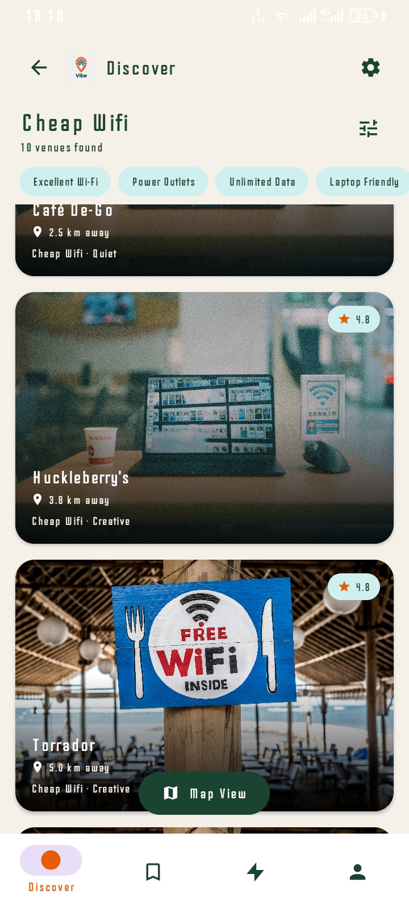

Cheap WiFi Discover Screen:
  - Shows the dynamic sub-tag filter pills adapting to the "Cheap WiFi" mood (e.g., Power Outlets, Laptop Friendly).

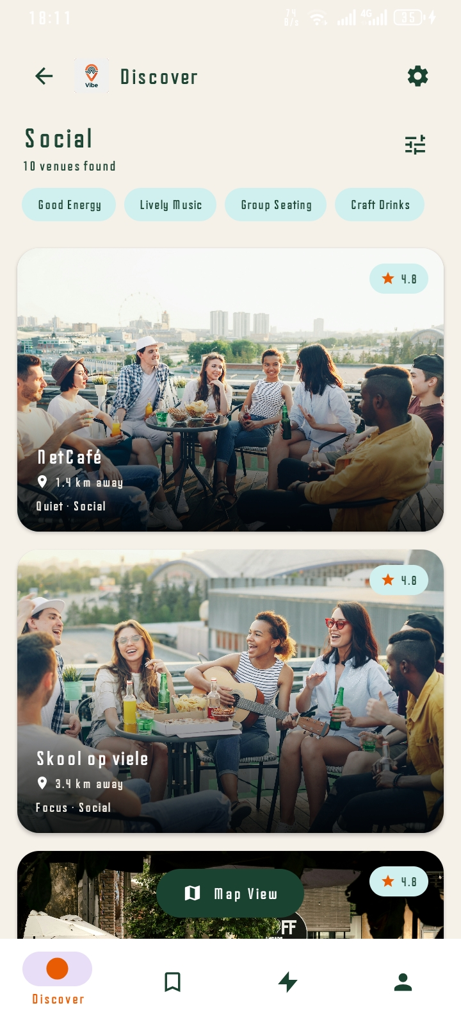

Social Discover Screen:
  - Shows the dynamic sub-tag filter pills adapting to the "Social" mood (e.g., Good Energy, Lively Music).

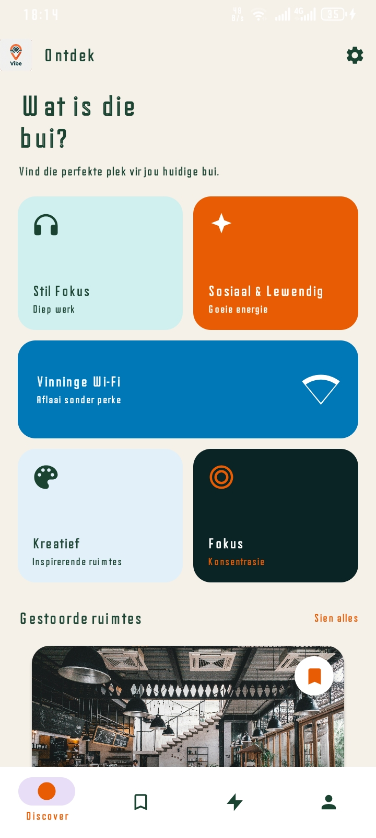

Afrikaans Home Screen:
  - Proves multi-language support with a fully translated Afrikaans UI.

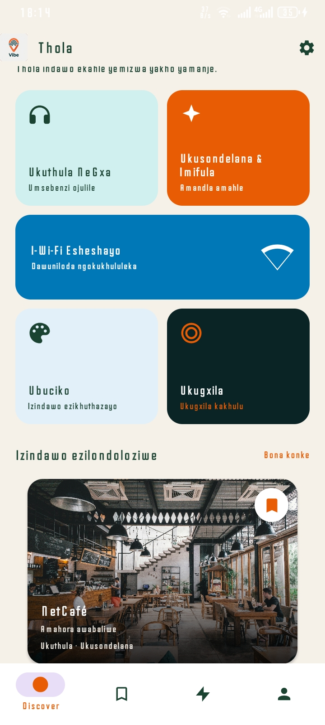

isiZulu Home Screen:
  - Proves multi-language support with a fully translated isiZulu UI, including localized mood categories.

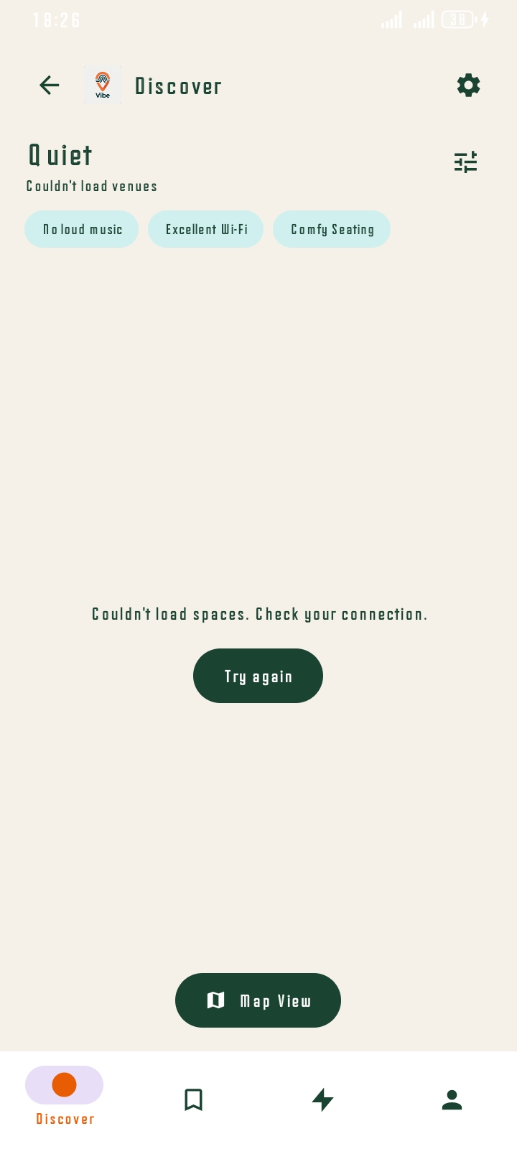

Error Handling Screen:
  - Demonstrates robust error handling with a user-friendly "Couldn't load spaces" message and a "Try again" button instead of crashing.

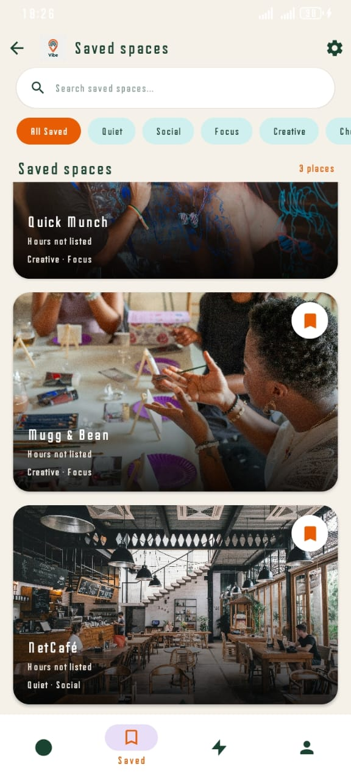

Saved Spaces Screen:
  - Showcases the offline-first "Saved Spaces" UI with dynamic filtering (All Saved, Quiet, Social) and visual bookmarks.



- Push Notification Screen:
  - Displays a real-time Firebase Cloud Messaging (FCM) push notification alerting the user to a new "Quiet Spot" nearby.

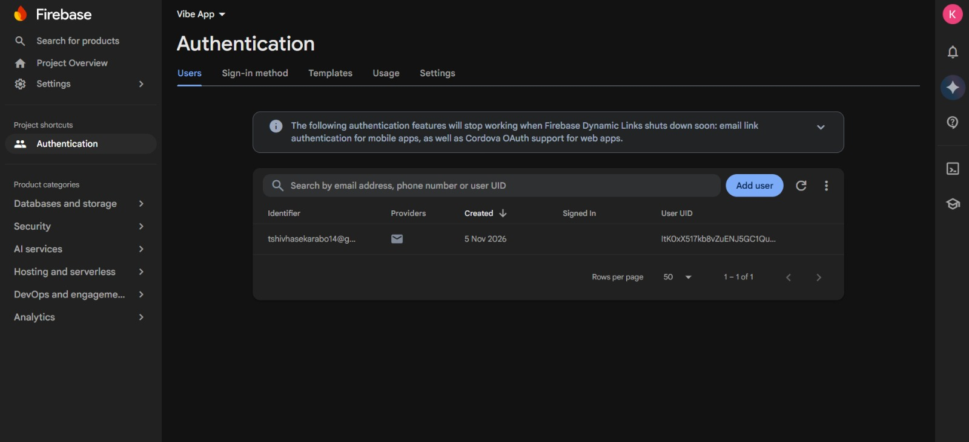

Firebase Authentication Screenshot:
  - Confirms secure user registration via Firebase Auth, displaying the registered email and unique User UID.

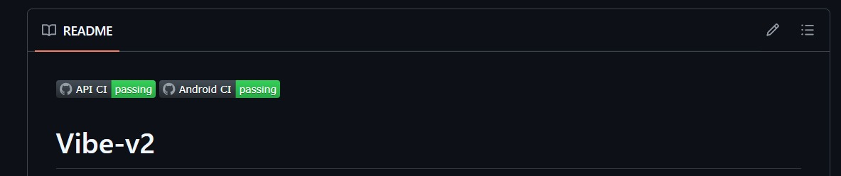
GitHub CI Badges Screenshot:
  - Shows the README status badges confirming that both the Android and API CI pipelines are passing.

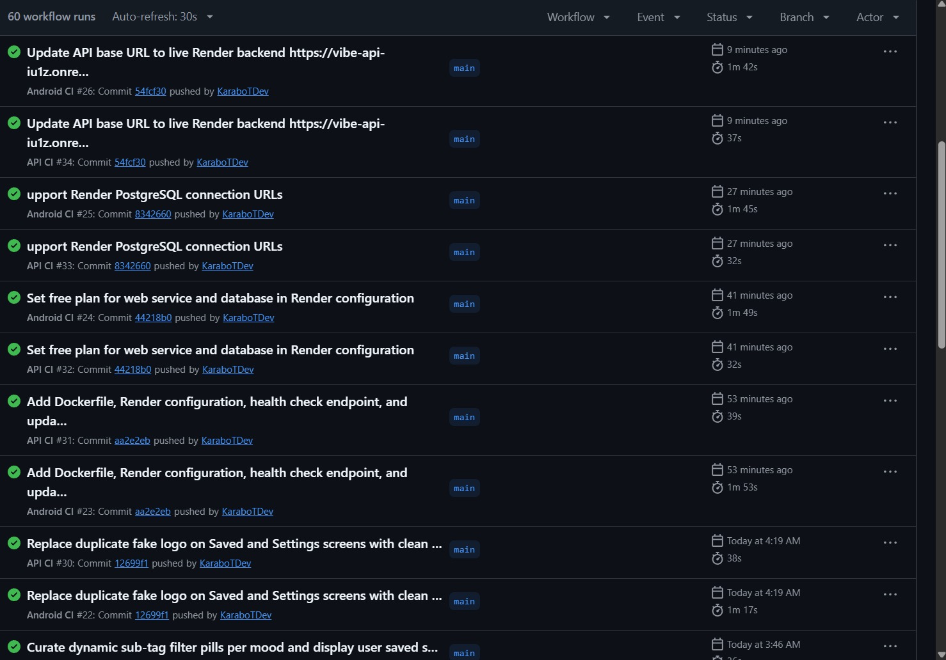
GitHub Actions Screenshot:
  - Provides evidence of automated CI/CD pipelines, showing successful builds and deployments for both the Android app and API.

Demonstration Video link

Conclusion
Vibe was designed to address the gap in everyday, purpose-driven venue discovery by allowing users to search for spaces according to mood and activity. The final implementation extends the original design through an improved visual discovery feed, contextual filters, multilingual support, offline favourites, push notifications, Google Sign-In, map integration and a deployed backend. This updated document records the transition from the original planning specification to the final build and identifies the evidence and README content required for the final Portfolio of Evidence.

References
BizData. (2026). BizData API documentation. Available at: https://bizdata-web.vercel.app
Microsoft. (2026). ASP.NET Core documentation. Available at: https://learn.microsoft.com/aspnet/core
Google. (2026). Firebase Cloud Messaging documentation. Available at: https://firebase.google.com/docs/cloudmessaging
PostgreSQL Global Development Group. (2026). PostgreSQL documentation. Available at: https://www.postgresql.org/docs/

